General Welfare Requirement: Safeguarding and Promoting Children's Welfare
The provider must promote the good health of the children, take necessary steps to prevent the spread of infection, and take appropriate action when they are ill.
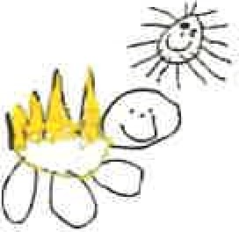
Gorran Pre School
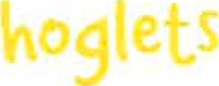
Promoting health and hygiene

1.17 Nappy changing
Policy statement
No child is excluded from participating at Gorran Pre-School Hoglets who may, for any reason, not yet be toilet trained and who may still be wearing nappies or equivalent. We work with parents towards toilet training, unless there are medical or other developmental reasons why this may not be appropriate at the time.
We make necessary adjustments to our bathroom provision and hygiene practice in order to accommodate children who are not yet toilet trained.
We see toilet training as a self-care skill that children have the opportunity to learn with the full support and non-judgemental concern of adults.
EYFS key themes and commitments
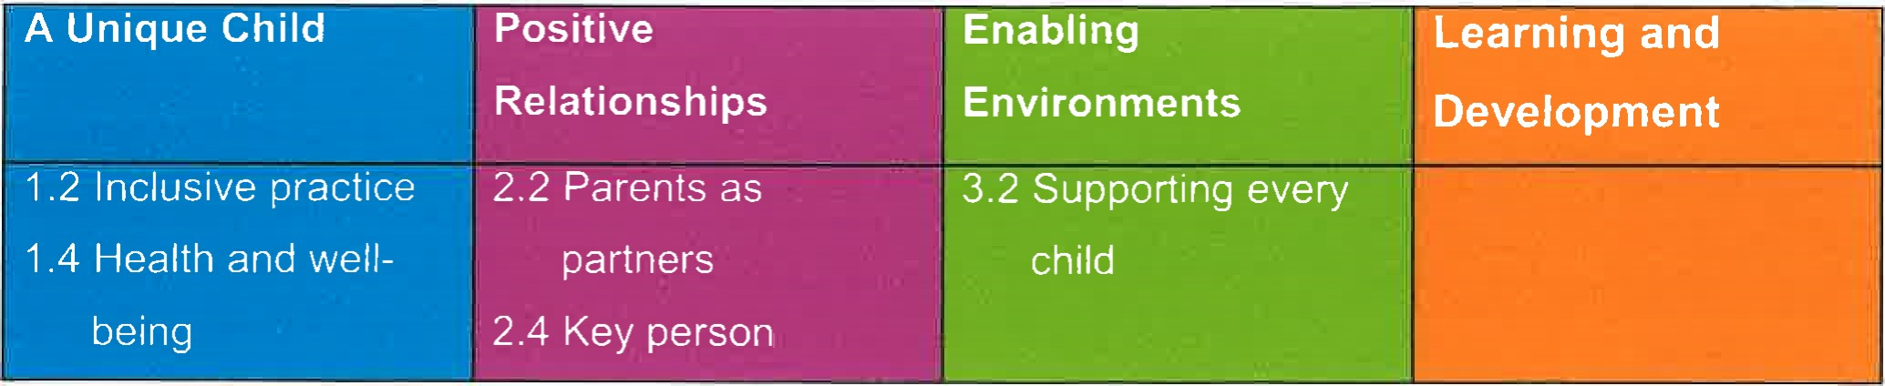
Procedures
- Key persons have a list of personalised changing times for the young children in their care who are in nappies.
- Young children from two years should wear pants as soon as they are comfortable with this and their parents agree.
- Key persons undertake changing young children in their key groups; back up key persons change them if the key person is absent.
- Changing areas are warm and there are safe areas to lay young children if they need to have their bottoms cleaned.
Each young child has their own bag to hand with their nappies and changing wipes.
Gloves and aprons are put on before changing starts and the areas are prepared.
All staff are familiar with the hygiene procedures and carry these out when changing nappies.
In addition, key persons ensure that nappy changing is relaxed and a time to promote independence in young children.
- Young children are encouraged to take an interest in using the toilet; they may just want to sit on it and talk to a friend who is also using the toilet.
They should be encouraged to wash their hands and have soap and towels to hand. They should be allowed time for some play as they explore the water and the soap.
- Anti-bacterial hand wash liquid or soap should not be used for young children.
Key persons are gentle when changing; they avoid pulling faces and making negative comment about 'nappy contents'.
Key persons do not make inappropriate comments about young children's genitals when changing their nappies
Older children access the toilet when they have the need to and are encouraged to be independent.
- Nappies and are disposed of hygienically. Any soil (faeces) in nappies is flushed down the toilet and the nappy is bagged and put in the bin. Cloth nappies, trainer pants and ordinary pants that have been wet or soiled are rinsed and bagged for the parent to take home.

This policy was adopted at a meeting of

Held on October 2019
Date to be reviewed October 2020

Signed on behalf of the management committee
Name of signatory
Gorran Pre-School Hoglets

Michelle Beard

Role of signatory (Manager) Pre-School Leader/Nominated Person

